
Please fill out this form completely and accurately. This information is essential to helping the doctor to develop a safe and effective program that addresses your needs, goals and interests. All information received on this form will be treated as strictly confidential.

Functional Nutrition Intake Form
Demographics
First Name |  | Middle |  | Last Name
Date of Birth |  | Age |  | Gender | ☐ Male ☐ Female
Mailing Address
City |  | State |  | Zip Code
Preferred phone |  |  |  | ☐ Home ☐ Work ☐ Cell
Height |  |  | Weight
Do you have pets? | ☐ None ☐ Dog ☐ Cat ☐ Other:
Email address
Referred by
What are you TOP 3 health and/or nutritional concerns?
1.
2.
3.
Are you currently under the care of a physician or other health care professional? |  |  |  |  | ☐ Yes ☐ No
If yes, please give name and date of last visit.

Medical History
Please check “yes” for any diagnosed health condition and the approximate date of onset.
CONDITION | YES | Date of Onset | CONDITION | YES | Date of Onset
GASTROINTESTINAL |  |  | INFLAMMATORY/AUTOIMMUNE
Irritable Bowel Syndrome |  |  | Chronic Fatigue Syndrome
Inflammatory Bowel Disease |  |  | Rheumatoid Arthritis
Crohn's Disease |  |  | Lupus SLE
Ulcerative Colitis |  |  | Frequent Infections
Celiac Disease |  |  | Severe Infectious Disease
Gastric or Peptic Ulcer Disease |  |  | Herpes
GERD, Reflux or Heartburn |  |  | Gout
Hepatitis C or Liver Disease |  |  | Other:
Food Intolerance |  |  | MUSCULOSKELETAL/PAIN
Other: |  |  | Osteoarthritis
RESPIRATORY |  |  | Chronic Pain
Asthma |  |  | Fibromyalgia
Chronic Sinusitis |  |  | Migraines
Sleep Apnea |  |  | Other:
Bronchitis or Emphysema |  |  | URINARY/REPRODUCTIVE
Tuberculosis |  |  | Kidney Stones
Other: |  |  | Urinary Tract Infections
CARDIOVASCULAR |  |  | Yeast Infection
Heart Disease/Heart Attack |  |  | Prostate Problem
Stroke |  |  | Other:
Elevated Cholesterol |  |  | METABOLIC/ENDOCRINE
Irregular Heart Rate |  |  | Type 1 Diabetes
High Blood Pressure |  |  | Type 2 Diabetes
Other: |  |  | Metabolic Syndrome
NEUROLOGICAL/BRAIN |  |  | Hypoglycemia
Depression |  |  | Hypothyroidism
Anxiety |  |  | Hyperthyroidism
Bipolar Disorder |  |  | Polycystic Ovarian  Syndrome
ADD/ADHD |  |  | Infertility
Multiple Sclerosis |  |  | Other:
Seizures |  |  | OTHER
Anorexia Nervosa |  |  | Chronic Ear Infections
Bulimia |  |  | Chicken Pox/Shingles
Parkinson's Disease |  |  | Bells Palsy
Other: |  |  | Epstein Barr
 |  |  | Mononucleosis
DERMATOLOGICAL |  |  | CANCER: Please list type(s) and treat-
Eczema
Psoriasis
Acne
Other:
Have you ever had an organ removed?
Organ | YES | Date | CONDITION | YES | Date
Tonsils |  |  | Colon
Appendix |  |  | Uterus
Thyroid |  |  | Ovary
Gall Bladder |  |  | Other:
Please list other previous injuries, surgeries and hospitalizations. Provide your age and date, if known.
Your Birth History: ☐ Vaginal ☐ C-Section |  |  | Were you breastfed as an infant? ☐ Yes ☐ No

Family History
Have any of your close relatives (parents, sibling, child, grandparent) been diagnosed with the following? Please check, describe and provide age of onset for those that apply.
Condition | Family Member(s) | Condition | Family Member(s)
Heart Disease |  | Cancer
High Blood Pressure |  | Overweight
Food Intolerances |  | Stroke
Autoimmune Disease |  | Diabetes
Oral History
Do you visit a dentist twice per year? ☐ Yes ☐ No
Do your gums bleed when you brush your teeth, getting a pink toothbrush? ☐ Yes ☐ No
Do you have any silver/mercury amalgam fillings? ☐ Yes ☐ No

Known Allergies |  |  |  |  |  | Allergic Symptoms Experienced
Food
Medication
Supplement
Environmental
Medications: Please check any of the medications you are CURRENTLY taking
☐ Antacids |  | ☐ Anxiety |  |  | ☐ Blood Pressure |  | ☐ Heart Meds |  | ☐ Steroids
☐ Antibiotics |  | ☐ Anti-inflammatory |  |  | ☐ Laxatives |  | ☐ Cholesterol/Statin |  | ☐ Testosterone
☐ Antifungal |  | ☐ Aspirin |  |  | ☐ Diabetic/Insulin |  | ☐ Muscle Relaxers |  | ☐ Thyroid
☐ Antidepressents |  | ☐ Birth Control |  |  | ☐ Estrogen |  | ☐ Progesterone |  | ☐ Tylenol
☐ Other: |  |  |  |  |  |  |  |  | ☐ Ulcer Meds
Herb/Supplement |  |  | Year Started | Reason
Have you EVER had prolonged or regular use of? |  |  |  |  |  |  |  |  |  | Date
NSAIDS (Advil, Aleve, etc.), Motrin, Aspirin |  |  |  |  |  |  |  | ☐ Yes ☐ No
Tylenol |  |  |  |  |  |  |  | ☐ Yes ☐ No
Acid-blocking drugs (Zantac, Pepsid, Tums etc.) |  |  |  |  |  |  |  | ☐ Yes ☐ No
Antibiotics ˃ 3 times per year |  |  |  |  |  |  |  | ☐ Yes ☐ No
Antibiotics long term (˃ 1 month continuously)? |  |  |  |  |  |  |  | ☐ Yes ☐ No
Other: |  |  |  |  |  |  |  | ☐ Yes ☐ No

Lifestyle Information
Are you currently involved in an exercise program? ☐ Yes ☐ No |  |  | How often:
How many hours do you sleep on weeknights? ☐ <6 ☐ 6-8 ☐ 8-10 ☐ 10+
How many hours do you sleep on weekends? ☐ <6 ☐ 6-8 ☐ 8-10 ☐ 10+
Check which apply to you: ☐ Trouble falling asleep ☐ Wake up during the night ☐ Don’t feel rested
Rate your stress level: ☐ None ☐ Mild ☐ Moderate ☐ High ☐ Extreme
What helps you relax?
Chemical Exposures
What is your occupation?
Are you regularly exposed to any chemicals? ☐ Yes ☐ No
Any significant past or present exposure to substances such as recreational drugs or alcohol? ☐ Yes ☐ No
If yes, please explain:
Nutrition History
Have you ever had an appointment with a dietitian or nutritionist? ☐ Yes ☐ No
Have you changed your eating habits for a health reason? ☐ Yes ☐ No
If yes, please explain:
Are you currently following a particular diet or nutrition plan? ☐ Yes ☐ No
Nutrition History continued
Do you have any eating preferences?
☐ Vegan | ☐ Low Carb/Keto | ☐ Dairy Free |  | ☐ Intermittent Fasting
☐ Vegetarian | ☐ Low/No Sugar | ☐ Gluten Free |  | ☐ Other:
Do you avoid any particular foods? ☐ Yes ☐ No
If yes, please explain:
Do you have any adverse food reactions (intolerances or allergies)? ☐ Yes ☐ No
If yes, please describe:
Have you recently lost or gained weight? ☐ Yes ☐ No
If yes, please describe:
Do you have or have you had an eating disorder? ☐ Yes ☐ No
If yes, please describe:

Please check the following items which apply to you and indicate amount consumed:
☐ Coffee |  | ☐ Candy |  | ☐ Cigarettes
☐ Tea |  | ☐ Chocolate |  | ☐ Other Tobacco
☐ Soda |  | ☐ Ice Cream |  | ☐ Alcohol
☐ Water |  | ☐ Sweetener |  | ☐ Sugar

Intake Summary
What type(s) of protein do you consume most days of the week? (Check all that apply)
☐ Red Meat ☐ Chicken/Turkey ☐ Pork ☐ Soy-based ☐ Dairy ☐ Nuts & Seeds ☐ Eggs ☐ Beans
How many servings of fruit do you have in a day? |  |  |  |  | ☐ 0-1 ☐ 2-3 ☐ 4-6 ☐ 6+
How many servings of vegetables do you have in a day? |  |  |  |  | ☐ 0-1 ☐ 2-3 ☐ 4-6 ☐ 6+
How many meals do you eat each day? |  |  |  |  | How many snacks do you eat each day?
How many meals do you buy from a restaurant or fast food per week? |  |  |  |  | ☐ 0-1 ☐ 2-3 ☐ 4-6 ☐ 6+
How many desserts do you have in an average week? |  |  |  |  | ☐ 0-1 ☐ 2-3 ☐ 4-6 ☐ 6+
What is your favorite meal?
Check all of the factors that apply to your eating habits and current lifestyle:
☐ Love to eat |  | ☐ Fast eater |  |  | ☐ Live alone or eat alone often
☐ Love to cook |  | ☐ Erratic eating patterns |  |  | ☐ Do not plan meals or menus
☐ Emotional eater |  | ☐ Eat too much |  |  | ☐ Time constraints
☐ Late night eater |  | ☐ Rely on convenience foods |  |  | ☐ Travel frequently
☐ Struggle with eating issues |  | ☐ Eat fast food frequently |  |  | ☐ Don't know how to cook
☐ Family members have different tastes |  | ☐ Make poor snack choices |  |  | ☐ Negative relationship with food
 |  | ☐ Confused about food/nutrition |  |  | ☐ Dislike healthy food
Food Diary: Please record what you eat and drink during one 24 hour period that represents a typical day.
Please be sure to include all beverages, cream and sweetener added to beverages and condiments added to foods.
What time do you wake up: | Bedtime: |  | Indicate the following:
Time | Food/Beverage |  | Homemade |  |  |  | Frozen Pre-Packaged |  |  |  | Take out  Fast Food  Restaurant
WOMEN ONLY
Does your menstrual cycle occur monthly? ☐ Yes ☐ No
If yes, cycle occurs every how many days?
Period lasts how many days?
Please indicate any of the following:
☐ Cysts |  | ☐ Endometriosis |  |  | ☐ Night sweats
☐ Fibroids |  | ☐ Bloating |  |  | ☐ Hot flashes
☐ Severe Cramping |  | ☐ Mood swings/Irritability |  |  | ☐ Fertility issues
☐ Heavy bleeding |  | ☐ Breast tenderness |  |  | ☐ Fertility treatments
☐ Fatigue |  | ☐ Abnormal pap |  |  | ☐ Other:
MEN ONLY
Have you had a vasectomy? |  |  |  |  |  |  |  | ☐ Yes ☐ No
Do you have a history of prostate problems? |  |  |  |  |  |  |  | ☐ Yes ☐ No
Do you have any trouble with urination? |  |  |  |  |  |  |  | ☐ Yes ☐ No
Have you had fertility problems? |  |  |  |  |  |  |  | ☐ Yes ☐ No
Do you have a history of erectile dysfunction? |  |  |  |  |  |  |  | ☐ Yes ☐ No
ALL PATIENTS- Readiness Assessment.
To improve your health, how ready/willing are you to …
1 (not willing) to 5 (very willing) |  |  |  | 1 |  | 2 |  |  | 3 | 4 |  | 5
Significantly modify your diet
Take nutritional supplements each day
Keep a record of everything you eat each day
Modify your lifestyle (ex: work demands, sleep habits, physical activity)
Practice relaxation techniques
Engage in regular exercise/physical activity
Have periodic lab tests to assess your progress
Patient Signature: _______________________________________ Date: _____________

Welcome to Wellness Nature’s Way
Nutrition Response Testing
In order for us to give you the attention you deserve on your path to wellness, we ask you to please be aware of our Mission, Philosophy, and Policies:
Mission: At Wellness Nature’s Way, we believe in partnering with our patients and their families to define and attain their health goals.
Philosophy: To educate and empower you to live in optimal wellness This approach is comprehensive and compliments any existing health care program.
INITIAL: POLICIES:
___________ Tardiness: Please be courteous and arrive on time for your scheduled appointment. Late arrivals force us to deduct time from your appointment in order to keep the schedule for other clients throughout the day. Anyone arriving more than five minutes past their scheduled time will need to rebook their appointment.
__________ Cancellations: We require a minimum of 24 hours advance notice for any cancellation or rescheduling of your appointment. This is a consideration to our practitioners. Less than 24 hour notice will result in an office visit charge.
Payment of Services: Payment in full is expected at the time of service.
Returned Checks: A standard fee of $25.00 will be charged for any returned checks.
I have read and understand the office mission, philosophy and policies.
Print Name: _____________________________ Date: __________________
Signature: _________________________________________________________

Cancellation & No-Show Policy
At Wellness Nature's Way Functional Medicine Clinic, we value your time and aim to provide the highest level of care. In order to maintain the quality of our services and accommodate other patients, we kindly request that you notify us of any changes to your appointment as early as possible.
Cancellation Policy:
- Cancellations made less than 24 hours before the scheduled appointment time will result in a full charge for the service to the credit card on file.
- No-shows will also be charged the full amount of the service to the credit card on file.
We understand that unexpected circumstances may arise, and we truly appreciate your cooperation and understanding in this matter. By adhering to this policy, you help us maintain an efficient and effective scheduling system for all our patients.
Thank you for choosing Wellness Nature's Way Functional Medicine Clinic. We look forward to continuing to serve your health and wellness needs.
Account Type: VISA MASTERCARD DISCOVER AMEX
Cardholder Name: __________________________________________________________
Credit Card Number: __________________________________________________________
Expiration Date: ___________________________
CVV: ___________________________
Signature: ____________________________ Date: ___________________________
I authorize Wellness Nature’s Way to charge the credit card indicated in this authorization form according to the terms & conditions outlined above. Payment authorization is for appointments cancelled less than 24 hours from scheduled date and no shows. I certify that I am the authorized user of this credit card and I will not dispute the payment with my credit card company.

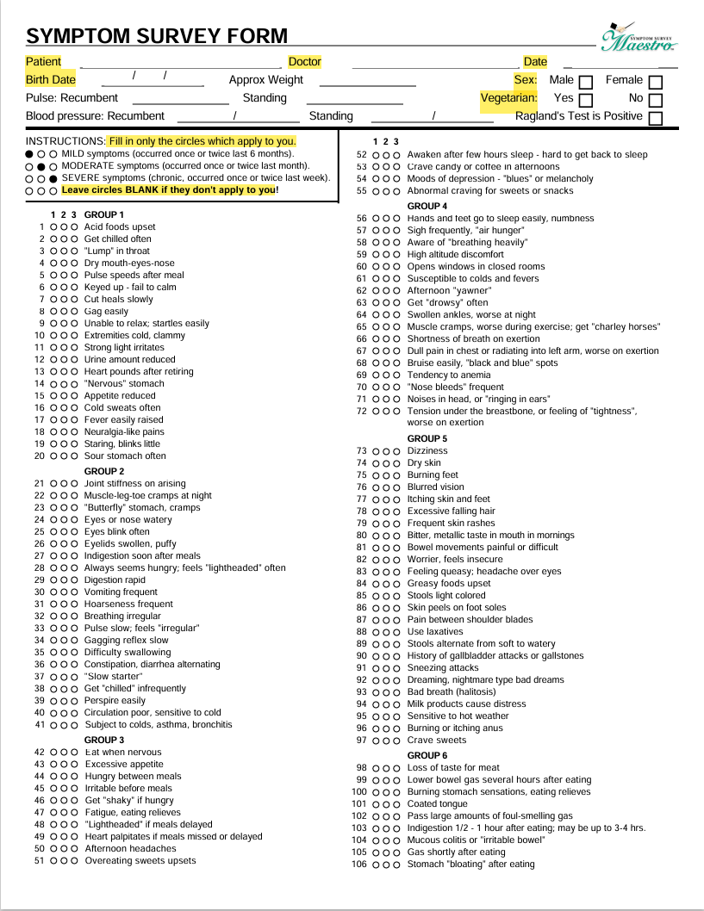
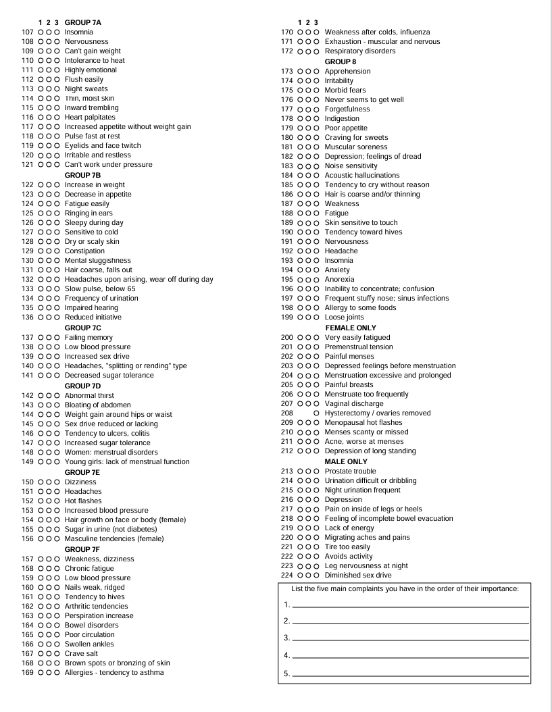

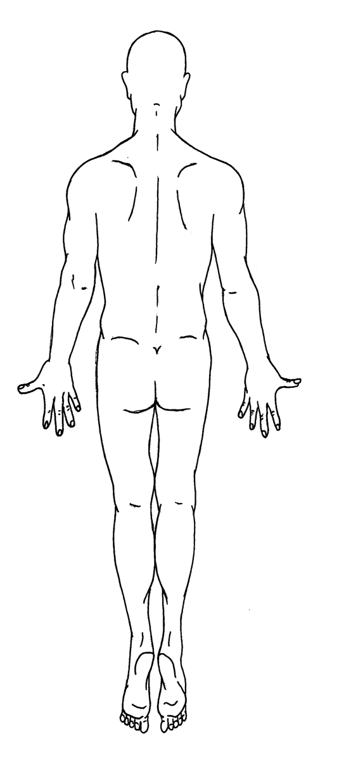
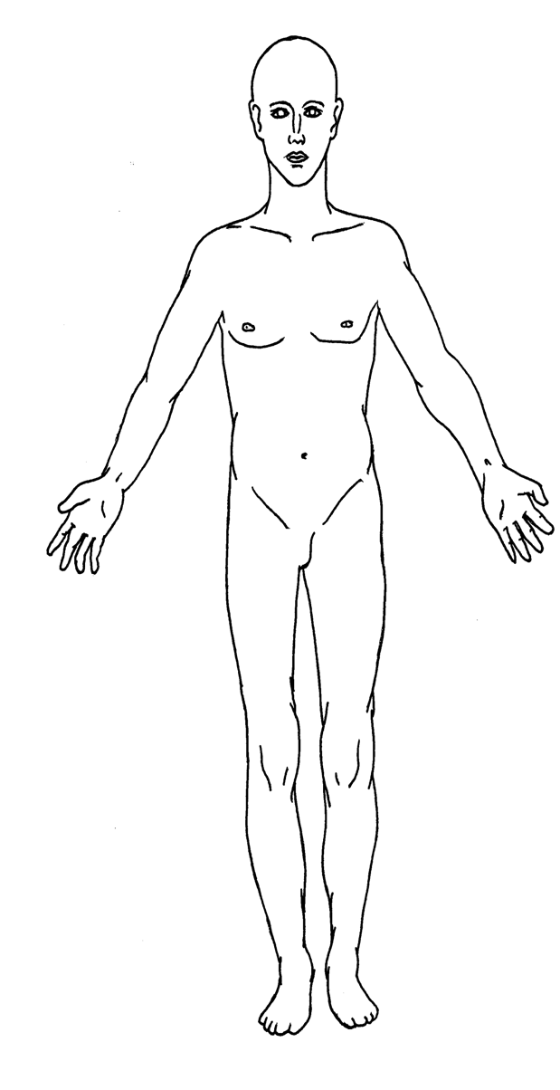
Name:___________________________________________ Date:__________
Place an X on the area of your body that you have a scar
Notes:

Wellness Nature’s Way
580-330-8038

PERMISSION & AUTHORIZATION FORM
REGARDING THE USE OF
NUTRITION RESPONSE TESTING®

PLEASE READ BEFORE SIGNING:

I specifically authorize the natural health practitioners at the Natural Health Improvement Center to perform a Nutrition Response Testing health analysis and to develop a natural, complementary health improvement program for me which may include dietary guidelines, nutritional supplements, etc. in order to assist me in improving my health, and not for the treatment, or "cure" of any disease.

I understand that Nutrition Response Testing is a safe, non-invasive, natural method of analyzing the body's physical and nutritional needs, and that deficiencies or imbalance in these areas could cause or contribute to various health problems.

I understand that Nutrition Response Testing is not a method for "diagnosing" or "treating" of any disease including conditions of cancer, AIDS, Infections, or other medical conditions, and that these are not being tested for or treated.

No promise or guarantee has been made regarding the results of Nutrition Response Testing or any natural health, nutritional or dietary programs recommended, but rather I understand that Nutrition Response Testing is a means by which the body's natural organ responses can be used as an aid to determining possible nutritional imbalances, so that safe natural programs can be developed for the purpose of bringing about a more optimum state of health.

I have read and understand the foregoing.

This permission form applies to subsequent visits and consultations.
Date:
Print Name:
Address:
City State Zip
Phone: (____) _____ -
Signed:
(If minor, signature of parent or guardian required)
Witness:

